Oldham’s Housing Delivery Action Plan: Part One

July 2024
- Contents
1 Introduction 3
2 Housing Needs 9
A National Picture 9
Oldham Context 10
3 Housing Delivery 16
Housing Requirement 16
Housing Completions 18
Implementation of Planning Permissions 20
Size of sites coming forward 22
Build-out Rates 25
4 Housing Land Supply Analysis 27
Housing Land Supply 27
Current Position of Housing Allocations 29
Lapsed and Stalled Sites 30
Housing Land Supply by Land Use 31
Housing Land Supply by Type 33
Housing Land Supply by Size 34
Housing Land Supply by Owner 37
Five-year Housing Land Supply Position 38
5 Engagement 40
6 Summary of housing delivery and supply issues in Oldham 42
7 Appendices 44

- Introduction
Purpose of the Report
  - This Action Plan provides an analysis of housing delivery across Oldham and identifies potential housing delivery issues within Oldham (set out in Part 1). Part 2 (which is contained in a separate document) sets out how the council intends to improve delivery to ensure that we provide a diverse Oldham Housing Offer which is attractive and meets the needs of different sections of the population at different stages of their lives.
  - The Housing Delivery Test (HDT) was introduced by the Government as a monitoring tool to demonstrate whether local areas are building enough homes to meet their housing need. The HDT measures net additional dwellings provided over the past three years against the number of homes required over the same period. Results on performance for each local planning authority in England are published annually.
  - The consequences of failing the Test are set out in the revised National Planning Policy Framework (NPPF) and are:
- less than 95% - an Action Plan must be prepared;
- less than 85% - the Local Planning Authority (LPA) must identify a 20% buffer of additional deliverable sites for housing on top of their existing 5-year housing land supply. This is in addition to an Action Plan but can form part of the 6-10 and 10 years plus supply, moved forward.
- less than 75% - the presumption in favour of sustainable development must be applied. This is in addition to the 20% buffer and Action Plan.
  - The latest HDT results were published on 19 December 2023, by the Department for Levelling Up, Housing and Communities (DLUHC) using the previous three complete financial years of 2019/20, 2020/21 and 2021/2022. The results for Oldham are shown in Table 1 below.
Table 1: Housing Delivery Test: 2022 Measurement (published December 2023)
 | Total number of homes required (2019-2022) | Total number of homes delivered (2019-2022) | Housing Delivery Test: 2022  Result | Housing Delivery Test 2022  Consequence
Oldham | 1,772 | 1,615 | 91% | Action Plan

  - The number of homes required in 2019/20 was 633. The number of homes required in 2020/21 was 461. The number of homes required in 2021/22 was 677. Therefore, the total number of homes required for 2019-2022 was 1,772 homes.
  - It is important to note that the impact of Covid-19 on housing delivery has been considered and is reflected in the 2022 results, as the ‘number of homes required’ was reduced within the 2019 to 2020 year by a month and within the 2020 and 2021 year by 4 months. The thresholds for consequences for under-delivery have been maintained, as set out in NPPF (see paragraph 1.3 above).
  - Oldham Council has delivered 91% of the homes required over the measurement period. As a result, considering the HDT consequences, the council is required to prepare an Action Plan to assess the cause of under-delivery and identify actions to increase delivery in future years.
  - An Action Plan is intended to be a practical document, focused on effective measures aimed at improving delivery within an area underpinned by local evidence and research of key issues. This Action Plan updates the previous Action Plan published in January 2022 and is Oldham’s fourth plan.
Relationship to other Strategies and Plans

  - This Action Plan complements several existing council aims, plans, policies and strategies which together provide a framework for the delivery of the council’s housing priorities. These are summarised below.
Oldham’s Housing Crisis
  - In February 2024 Oldham Council declared a housing crisis. The national housing crisis is having a local impact within Oldham. As is set out within section 2 of this document, there are several components of the national housing crisis, including a significant under-supply of housing, worsening affordability (and a lack of affordable housing options), an ageing population and the increased cost of living.
  - These issues are being experienced within Oldham. Currently there is a need for 8,164 homes on the Council’s Housing Needs Register, but only 1,211 homes available. There are increasing numbers of people in temporary accommodation – between June 2020 and March 2024 the number of people in temporary accommodation increased by over 170%. Further analysis of Oldham’s housing needs is contained within section 2 of this document.
  - There is a particular need for social homes within Oldham. Social homes are considered to be a truly affordable housing option.
  - The number of social homes being built across England has dramatically reduced over the past decade. Shelter have reported that the severe lack of social housing is the main cause of England’s housing crisis. Social homes being sold off and not replaced, insufficient funding for social homes compared to other types of affordable products (including shared ownership and affordable rent – as defined by NPPF), and not building enough social homes, are identified as the main reasons for the distinct shortage of social homes across England.
  - As part of their ‘let’s build social housing’ campaign, Shelter have stated that if the government supported the delivery of 90,000 social homes per year across the country, this would lead to significant improvements in the housing crisis and ensure people have a solid foundation to lead happy and healthy lives.
  - At a Housing Roundtable event, Oldham Council committed to doing our bit to resolve the housing issues being experienced within Oldham, by delivering 500 social homes, with the support of council partners, over the next five years. Further information about the event is set out within section 5 of this document.
  - In addition to the commitment to deliver social homes, our response to the housing crisis includes a series of other priorities which are aimed at meeting local housing needs, including tackling empty homes - bringing them back into use, and identifying a residential pipeline of future housing sites across the borough and supporting their delivery for a range of housing types.
  - This Action Plan is framed in the context of Oldham’s housing crisis declaration and actions within this Action Plan (contained in part 2) are directly related to meeting Oldham’s local housing needs. Further information and progress on the actions are included within part 2 of this Action Plan.
Oldham’s Housing Strategy

  - The Council’s Housing Strategy 2019 aims to provide a diverse Oldham Housing Offer that is attractive and meets the needs of different sections of the population at different stages of their lives.
  - The Housing Strategy sets out the opportunities that the council, and its partners, have to improve our housing offer and our place offer. These include:
- Building new homes at a level which increases the housing choices available so that more people can find a suitable home in a place they like and at a price they can afford.
- The delivery of a broader range of housing tenure and type, particularly in the most disadvantaged areas, to reduce social and economic segregation and achieve a better mix of incomes.
- Explore new housing development models, such as a Local Housing Company and alternative financial incentive schemes.
  - To meet these challenges, and more, the Housing Strategy sets out a series of actions, which include those around:
- Building more homes to provide greater choice in type, size, tenure and affordability.
- Partnerships with committed developers and registered housing providers to build homes and better places.
- Improving the viability of difficult sites with developers.
- Support for self-build and co-operative community-led models of housing. The council’s direct role in the delivery of new homes.
- Improve coordination between housing and planning.
  - These actions are supported by a delivery plan which facilitate their implementation. The Housing Delivery Test Action Plan is not intended to repeat the Housing Strategy Delivery Plan but supports its implementation as appropriate.
  - As part of the Housing Strategy, a Local Housing Needs Assessment (LHNA) was prepared. This provided an in-depth analysis of Oldham’s housing market and housing needs. An update of the LHNA for 2023/2024 has been prepared and will be available online in due course. Findings from the updated LHNA are noted throughout this Action Plan where appropriate.
  - The council intends to refresh the Housing Strategy in the near future to respond to the housing crisis and to embed the findings of the LHNA update. This will inform future Housing Delivery Action Plans as appropriate.
Creating a Better Place (Oldham Council)
  - 'Creating a Better Place' is an ambitious plan for Oldham. Creating a Better Place focuses on building more homes for our residents, creating new jobs through town centre regeneration, and ensuring Oldham is a great place to visit with lots of family-friendly and accessible places to go.
  - Creating a Better Place aims to deliver around 2,000 new homes in the town centre designed for a range of different budgets and needs, new job and entrepreneur opportunities, new leisure, retail and cultural facilities and a new park.
Oldham Town Centre Development Plan Framework (Oldham Council & Muse)
  - Building on the vision of Creating a Better Place, Oldham Council has partnered with Muse, the placemaker, to deliver transformational change for the town centre.
  - Informed by Oldham Council’s wider regeneration initiatives and planning policy context (both adopted and emerging), the Framework sets out a series of town centre wide development principles together with site specific design principles and illustrative proposals for defined council owned assets across the town centre.
  - The Development Framework will act as a guide to future development across the town centre and considers infrastructure interventions and technical studies to assist in the delivery of the key sites. As the Framework develops, it will inform the assessment of sites, including indicative capacities and delivery timescales, within the SHLAA. The Framework will also inform relevant policies and site allocations within the Local Plan Review.
Oldham’s Local Plan
  - The current Local Plan was adopted in November 2011. The council is in the process of reviewing the Local Plan. A new Draft Local Plan has recently been consulted upon and the feedback will be used to prepare the Publication Plan. Updates on the Local Plan timetable will be made available on the council’s website and as part of the Local Development Scheme.
‘Places for Everyone’ Joint Development Plan Document
  - Places for Everyone (PfE) is a joint development plan for nine Greater Manchester districts (Bolton, Bury, Manchester, Oldham, Rochdale, Salford, Tameside, Trafford and Wigan).
  - It sets out how the nine districts should develop up until 2039 and:
- Identifies the amount of new development that will come forward across the nine districts, in terms of housing, offices, industry and warehousing, and the main areas in which this will be focused;
- Supports the delivery of key infrastructure, such as transport and utilities;
- Protects the important environmental assets across the nine districts;
- Allocates sites for employment and housing outside of the existing urban area; and
- Defines a new green belt boundary for the nine districts.
  - Places for Everyone was adopted by all nine districts on 21 March 2024, becoming part of Oldham’s statutory development plan from this date.
  - PfE sets out the housing requirement for each of the nine districts and also identifies the housing land supply, the distribution of housing land, the phasing of new housing development, and includes policies on affordability, type, size and design of new housing and housing density.

Approach
  - The remainder of the Action Plan includes the following:
- Housing need, delivery and supply analysis (contained in Part 1);
- A summary of findings and key issues related to housing delivery (contained in Part 1);
- Key actions and responses for improving housing delivery (contained in Part 2); and
- Project management and monitoring arrangements (contained in Part 2)

- Housing Needs

  - This section provides an analysis of housing need issues, including affordable housing and housing for older people, in the borough.

A National Picture

  - There is a need to deliver housing to meet specific housing needs, such as homes for older people, affordable homes and homes for families.
  - There are several significant issues affecting housing demand and provision at a national level which offer perspective to some of the acute housing issues being experienced in Oldham.
  - England has an ageing population. The proportion of people aged 65 years and over rose from 16.4% in 2011 to 18.6% in 2021. Whilst people are living longer, the number of years people can expect to live in good health (without a disabling illness) is declining. There are also inequalities in healthy life expectancy based on deprivation. With those living in more deprived areas also living shorter lives, this means that they spend a smaller proportion of their lives in good health, compared to people living in less deprived areas.
  - There is a national under-supply of housing. According to research there is a need for around 340,000 new homes per year in England, of which 145,000 should be affordable (up to 2031). The government has committed to reaching a supply of 300,000 homes per year by the mid-2020s. However, during 2022/23 around 234,400 new homes were supplied (similar to 2021/22). Housebuilding is not occurring at the rate required to meet housing needs.
  - Housing affordability is worsening. House prices have become less affordable over time with long term house price growth contributing to reduced affordability.
  - The latest published ONS figures (March 2023) show that in 2022, full-time employees in England could expect to spend around 8.3 times their annual earnings buying a home. Another recent report found this to be even higher, in that the average house in the UK currently costs 9.1 times average annual earnings. In terms of the north-west, house prices are around 7.5 times the average annual earnings.
  - Interest rates have also been increasing since the start of 2022, meaning the cost of mortgage repayments is increasing, further impacting affordability.
  - The cost of renting is also increasing - between October 2022 and October 2023 private rental prices paid by tenants increased by 6.1% across the UK. Around 40% of adults reported finding it very or somewhat difficult to afford their rent or mortgage payments in the latest pooled period.
  - ONS research has found that when asked what the most important issues facing the UK are, adults citied ‘cost of living’ most often and ‘housing’ fifth. 16% of adults reported that increased rent or mortgage costs has contributed to their overall increased cost of living (amongst the price of food shopping, gas and electricity and the price of fuel).
  - In terms of financial resilience (measured as being able to withstand a 25% fall in household employment income over a three-month period), over one quarter (27%) of households could not cover this. Households which were most likely to report this, and therefore considered the least financially resilient, were lone parents with dependent children (55%), renters (48%), households with a Black, African, Caribbean, or Black British head (53%), households where the head had a routine or semi-routine occupation (46%) and households where the head had a limiting disability or longstanding illness (34%).

Oldham Context
Demographic

  - In terms of demographics, Oldham’s population was estimated to be 241,176 in 2022.
  - According to the ONS, Oldham’s population is projected to reach 261,018 by 2041 – a 10% increase from the 2020 population. High birth rates within the Pakistani and Bangladeshi communities, along with internal and international migration, will be major influences in Oldham’s population growth.

Figure 1: Oldham’s Population Projections 2001 to 2041
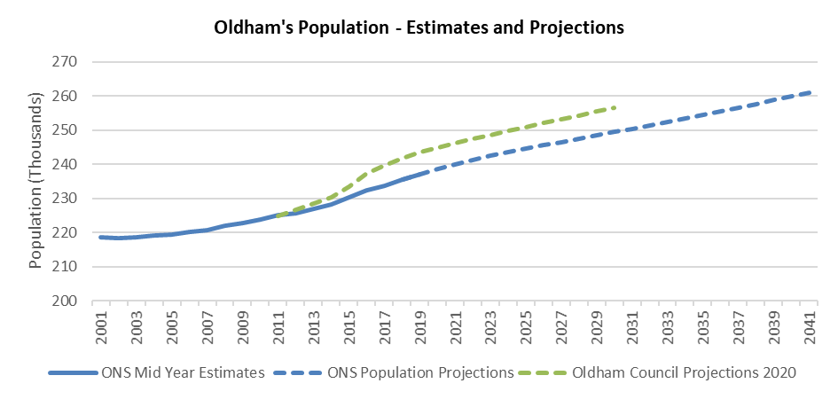

  - It is expected that the number of older people in Oldham will grow by 30% in the next 20 years. This will bring major challenges for adult social care, specialist housing and health provision.
  - Also, changes in Oldham’s ethnic composition are likely to affect patterns of residence within Oldham. There may be an increased need to support community relations, particularly within neighbourhoods where ethnic compositions are shifting rapidly.
  - Levels of deprivation across the borough are generally ranked amongst the highest in the country. Oldham currently has four areas within the borough which are among the top 1% of the nation’s most deprived areas. The majority of these areas are centred in and around the town centre, particularly within the wards of St Mary’s, Coldhurst and Alexandra. Only the wards of Crompton, Saddleworth North and Saddleworth South do not contain any areas that fall within the nation’s top 20% most deprived.

Figure 2: Oldham Areas of High Deprivation, 2019
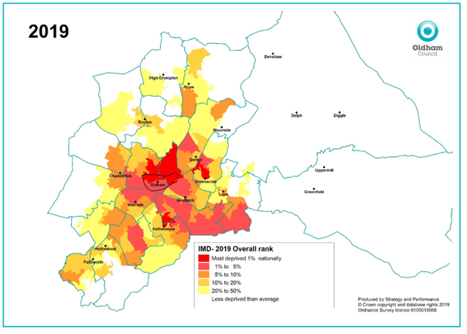

  - In terms of income, Oldham has traditionally had low wage levels. This is likely due to the industry mix within the borough and the relative skill levels of the local workforce. Average incomes within Oldham are amongst some of the lowest in Greater Manchester.
  - Life expectancy in Oldham is two years shorter than life expectancy across England and Oldham’s residents have worse health than England’s average. High levels of deprivation in the borough have a significant impact on health outcomes. There are also significant social inequalities within Oldham - 40% of people living in Coldhurst belong to an income-deprived household, whilst this is only around 5% in Saddleworth South. These social inequalities inevitably lead to health inequalities - the difference in life expectancy between the most and the least deprived wards in Oldham is over 12 years.
  - In addition, the number of years and proportion of life residents of Oldham are spending in poor health is increasing. This will impact on demands for services provided by the council, such as healthcare and Adult Social Care.
  - Oldham is estimated to have 93,152 households (as of 2021). The borough has an unbalanced housing market with low proportions of detached properties and a very high proportion of terraced homes – the highest in Greater Manchester.
  - Oldham has a need for larger family accommodation highlighted by the issues around over-crowding, particularly in South Asian communities, and this demand is expected to intensify over time. The 2021 Census identified that 7.5% of households in Oldham are overcrowded compared to 4.4% nationally. Large concentrations of overcrowded homes are located around the outskirts of the town centre, particularly in the wards of Coldhurst, St Mary’s and Werneth.
  - Approximately 71% of occupied homes are owner-occupied; 21% are rented from a social housing provider; 7.3% are private rented and 0.6% are intermediate tenure dwellings (i.e. shared ownership).
  - Housing tenure distribution varies considerably across the borough, with high concentrations of social housing in the more deprived communities and lower levels of affordable housing in more rural areas.
  - The private rented sector has expanded very quickly across Oldham as well as nationally due to rising house prices in relation to earnings and a dramatic fall in the number of homes being rented out by local authorities.
  - The median house price in Oldham as of March 2023 was £180,000 – less than the Greater Manchester average (£219,000) and significantly lower than the England average (£290,000). House prices in Oldham are some of the lowest in Greater Manchester, likely impacted by the large proportion of terraced properties which make up Oldham’s housing stock.
  - House prices, available housing stock and affordability (the ratio of earnings to house prices) vary significantly across Oldham. The median price paid in Saddleworth North, Oldham’s most prosperous ward, was £298,750, in contrast to St Mary’s – one of Oldham most deprived wards at £115,000. Over the last decade, the median house price paid in Oldham has increased by 66.7% from £108,000 in March 2013 to £180,000 in March 2023, compared with 75.2% in Greater Manchester and 56.8% nationally.
  - While house prices remain low compared to Greater Manchester, regional and national levels, they are still unaffordable for many Oldham residents due to low wages and high deposit requirements. In 2023, Oldham’s affordability ratio was 6.03, compared to 6.26 in 2022, 6.26 in 2021 and 5.1 in 2020. Meaning on average the price of a home in Oldham is now 6.03 times the average annual earnings. Oldham's affordability has been (on average) continually worsening since 2000, although it has improved slightly compared to 2022 and 2021.
  - In terms of renting, Oldham is amongst some of the ‘most affordable’ borough’s in Greater Manchester to rent a home, with the rental affordability ratio estimated at 31.08% (i.e. average rent costs are 31.08% of average monthly pay). However, the boroughs of Bury, Bolton, Rochdale and Wigan are all more affordable to rent in compared to Oldham.
  - Also, rising energy prices and energy-inefficient housing means a high portion of households in Oldham are in fuel poverty. Living in a cold home can have serious health implications, particularly for the old, very young and for people with disabilities and can even play a role in premature deaths. Fuel poverty is closely associated with low income and is most common among those who live in privately rented accommodation.
  - The following section sets out housing needs for particular groups.

Affordable Housing Need
  - The LHNA Update (2023/24) has found that there is a considerable shortfall of affordable housing. There is an annual need for 537 affordable homes a year (over the next 10 years). This is almost as high as our average housing requirement over the PfE plan period – 680 homes a year. Whilst it will be difficult to meet this target, it highlights the importance of the council having a robust affordable housing policy in place to help deliver against this affordable housing need and ensure that we deliver as much as we are able to.
  - There is a need for a range of affordable housing types – 37% should be 1 or 2 bedrooms, 43% should be 3-bedrooms and 21% should be 4-bedrooms.
  - We also need an appropriate tenure mix – development of affordable housing needs to focus on social or affordable rented properties with some affordable home ownership properties. A tenure split of 50% social or affordable rented and 50% affordable home ownership may be appropriate in terms of planning policy requirements.
  - At present, Oldham is experiencing increasing demand for social housing which is outstripping supply.
  - Currently there is a need for 8,164 homes on the Council’s Housing Needs Register, but only 1,211 homes available. The largest demand (and available supply) is for 1-bed, 2-bed and 3-bed housing.
  - There is also a demand for 4-bed to 7-bed homes, but there is very limited supply of larger homes. In fact, there is currently no available supply of 5+ bed housing to meet the needs of 126 applicants.
  - There are increasing numbers of people in temporary accommodation – between June 2020 and March 2024 the number of people in temporary accommodation increased by over 170% (219 households in June 2020 to 592 households in March 2024).

Specialist Housing Need
  - The LHNA update has also looked at the need for specialist housing, including housing for older people and disabled people.
  - It has found that there is a need for 4,523 additional units of accommodation for older people by 2039, including 702 residential care bedspaces, 905 Extra Care units and 2,916 other types of accommodation, including leasehold sheltered. The LHNA update recommends strengthening policies to enable people to live in their own homes for longer with appropriate support and adaptation.
  - It sets out that all new homes should be accessible and adaptable (M4(2) Standard), which would include bungalows/ level access accommodation, in line with policy JP-H3 of Places for Everyone. Also, that 5 % of all new homes should be wheelchair accessible (M4(3) Standard).
  - Further analysis of housing needs will be available within the LHNA update, when published, which will inform future Housing Delivery Action Plans as appropriate.

- Housing Delivery

  - This section provides an analysis of housing delivery against our housing needs and identifies unmet need and deficiencies.

Housing Requirement

  - The HDT looks at the number of homes delivered compared to the number of homes required over the previous three complete years, from the date of publication. The most recent measurement therefore looks at the period of 2019/20, 2020/21 and 2021/22.
  - Oldham’s housing delivery is tested against our local housing need figures for each year over that time, as shown in table 2 below. This is calculated using the government’s ‘standard methodology’ for calculating local housing need.
  - Oldham’s Housing Delivery Test results for the 2022 measurement are set out in table 2.
Table 2: Oldham’s Housing Delivery Test Results (2022 measurement)
Year | Number of Homes Required | Number of Homes Delivered | Average Delivery Rate (%)
2019/20 | 633 | 729 | 115%
2020/21 | 461 | 380 | 82%
2021/22 | 677 | 506 | 75%
Total (2019-2022)/ Average Delivery Rate % | 1,772 | 1,615 | 91%

  - As shown in table 2, housing delivery has been variable over the previous three years, however overall Oldham has delivered 91% of the housing required. This is the same as the 2021 HDT measurement result.
  - Since the introduction of the Housing Delivery Test in 2018, Oldham’s housing delivery has improved. The results for this year compared to previous years are set out in table 3 below.
Table 3: Oldham’s Housing Delivery Test Results (2018-2022)
HDT Measurement Year | Delivery Rate % (HDT Result)
2018 | 64%
2019 | 65%
2020 | 80%
2021 | 91%
2022 | 91%

  - As shown in table 3, on average the housing delivery rate has increased by 27% since the 2018 measurement.
  - Where a new housing requirement is adopted through a Local Plan, the HDT calculation will be calculated using these new targets and any consequences for under-delivery will be applied.
  - As of 21 March 2024, Places for Everyone (PfE) now sets out Oldham’s housing requirement for the plan period. PfE identifies a stepped housing requirement for Oldham of 404 homes per year for 2022-2025, 680 homes per year for 2025-2030, and 772 homes per year for 2030-2039. This equates to an annual average of 680 new homes per year.
  - Looking forward, based on the current methodology the 2024 HDT measurement would look back at years 2020/21, 2021/22 and 2022/23 to identify the number of new homes required and delivered. The housing requirement of 404 homes per year would apply for 2022/23, given that the plan period is 2022-2039. This would increase to two years of 404 homes per year for the 2025 HDT measurement (2022/23 and 2023/24) and so on. On this basis, and if delivery rates continue as they are or increase, performance would improve against the HDT 95% pass rate. However, the stepped housing requirement set out in Places for Everyone does mean that from 2025 this would increase to 680 homes a year.
  - Based on the identified housing land supply, as set out in the recently published Strategic Housing Land Availability Assessment (SHLAA) (2023), against the PfE stepped requirement, the housing land supply would be sufficient to meet the requirement for the first five years and the remainder of the plan period. However, whilst the SHLAA identifies land that may be suitable for housing, it does not in itself ensure that this housing is delivered. As such, supporting the delivery of housing to meet Oldham’s housing needs will be critical going forward, and we will need to consider how through the Action Plan this is addressed.

Housing Completions

  - Over the last ten years (2012/13 – 2021/22), prior to and including the most recent HDT measurement year (2021/22), 4,246 (net) new homes have been completed. This represents an average of 425 homes per year.
  - The number of net completions has fluctuated over the last ten years. After falling in 2015/16, completions increased again from 2016/17 as several larger sites began construction. Prior to this there were high levels of clearance due to regeneration activity during 2003/4 to 2012/13 together with changing economic conditions witnessed since 2008/09 that may have had an effect.
  - Completions for 2020/21 (373 homes) were significantly lower than the previous year 2019/20 (728 homes). It is likely that the impact of the Covid-19 pandemic and wider socio-economic issues may have contributed to the lower level of completions.
  - Whilst it is not included within the most recently published HDT measurement (2022), 403 homes were completed in 2022/23.
Figure 3: Housing Completions 2012/13 to 2021/22
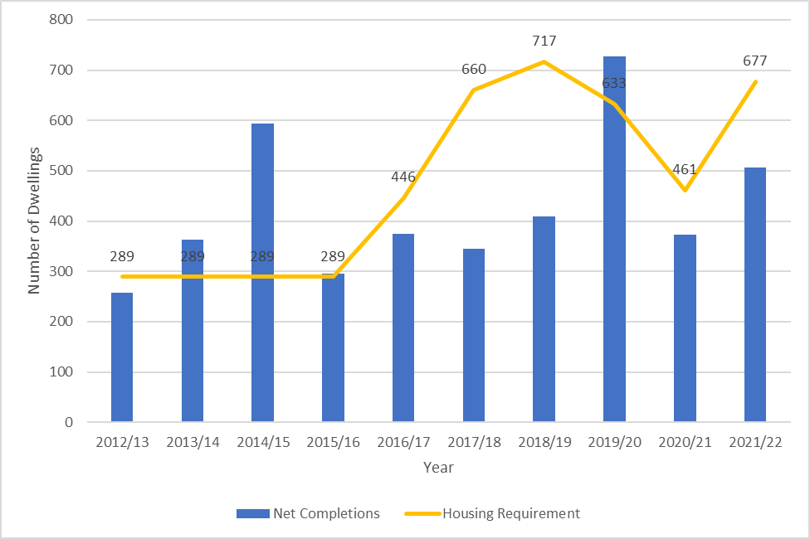

  - Over the period, 518 homes less than the required number of homes (4,750) have been delivered. As shown in figure 3, the number of completions has only exceeded the housing requirement five times in the 10-year period.
  - In terms of affordable housing specifically, table 4 shows that over the ten-year period (2012/13 to 2021/22) there have been 1,370 affordable homes delivered. On average over this period affordable homes represent a third (33%) of all homes delivered. It should be noted that this is defined as per the definition of ‘affordable housing’ in NPPF and can include several tenures.
Table 4: Affordable Housing Completions 2012/13 to 2021/22
Year | Total number of homes delivered | Number of affordable homes delivered | % of total homes delivered that were affordable tenure
2012/13 | 257 | 198 | 77%
2013/14 | 363 | 202 | 56%
2014/15 | 594 | 280 | 47%
2015/16 | 296 | 20 | 7%
2016/17 | 374 | 60 | 16%
2017/18 | 345 | 42 | 12%
2018/19 | 410 | 90 | 22%
2019/20 | 728 | 176 | 24%
2020/21 | 373 | 129 | 35%
2021/22 | 506 | 173 | 34%
Total | 4,246 | 1,370 | 33%

  - In addition, 156 affordable homes have been delivered in 2022/23 which represented 39% of all homes completed that year.
  - Affordable housing completions were lower for 2015/16 to 2018/19, following higher levels of affordable home development in years prior to 2015/16 because of Housing Market Renewal programmes, which have now completed.
  - Section 4 addresses the future supply of housing, including affordable housing.

Implementation of Planning Permissions
  - Figure 4 shows the rate of delivery compared to the number of homes granted planning permission each year over a ten-year period (2012/13 to 2021/22) against the requirement set out in the Local Plan and, more recently, the HDT requirement.
  - This has fluctuated over time and shows that:
- except for 2012/13, the number of new homes granted permission has far exceeded the adopted Local Plan housing requirement of 289 dwellings per year;
- during 2017/18 and 2018/19 the number of new homes granted permission was far less than the requirement for those years; and
- during 2019/20 and most recently, 2021/22, the number of new homes granted permission far exceeded the requirement for that year, whilst during 2020/21 it was only 16 homes less.

  - Over the period, approximately 760 sites have been granted planning permission, generating a potential yield of 6,292 homes. Just over half (3,826 homes or 61%) have been completed, although it must be borne in mind that 255 sites (or 2,108 homes) were only granted permission in the last three years. As such, there is still time for these to come forward.
  - Further analysis of the sites that have been granted permission for housing in the last ten years and the progress of these sites, shows that over this period an average of 12% have lapsed, meaning an equivalent of 626 homes cannot come forward unless a fresh application is submitted and granted. On average, every year since 2012/13 78 homes granted planning permission are not commenced.

Figure 4: Residential permissions compared to completions 2012/13 to 2021/22
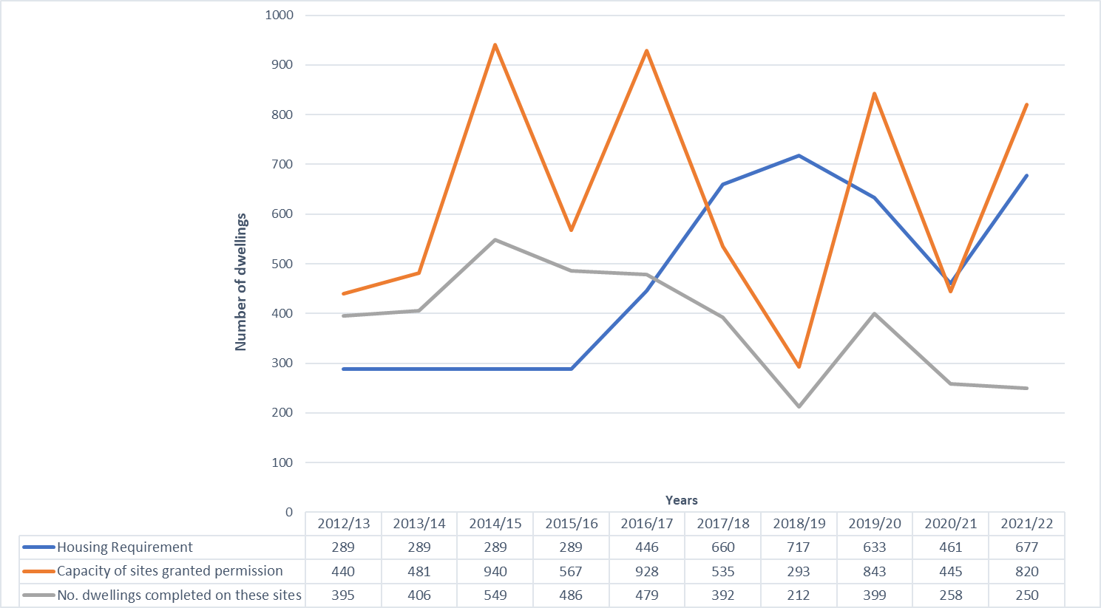

Size of sites coming forward
  - Analysis of ‘minor’ and ‘major’ residential development sites, shows that minor sites (of between 1 and 9 dwellings) make up 84% of the sites granted planning permission in the last 10 years. Major sites (of more than 10 dwellings) make up 15%. Figure 5 illustrates this.
  - Despite the above, figure 6 shows that 75% of the total number of homes granted planning permission over the last 10 years are on major sites. Therefore, whilst the number of major sites is relatively low, they form a significant proportion of our supply in terms of the number of new homes.
  - More detailed analysis shows that only 8% of dwellings granted permission on major sites have not been built and the planning permission has since expired, which is a lower lapse rate than the overall supply (12%). This includes two sites of over 50 dwellings, with a capacity for 251 new homes, where planning permission has expired without implementation.

Figure 5: Number of sites with planning permission for residential uses by site size 2012/13 to 2021/22
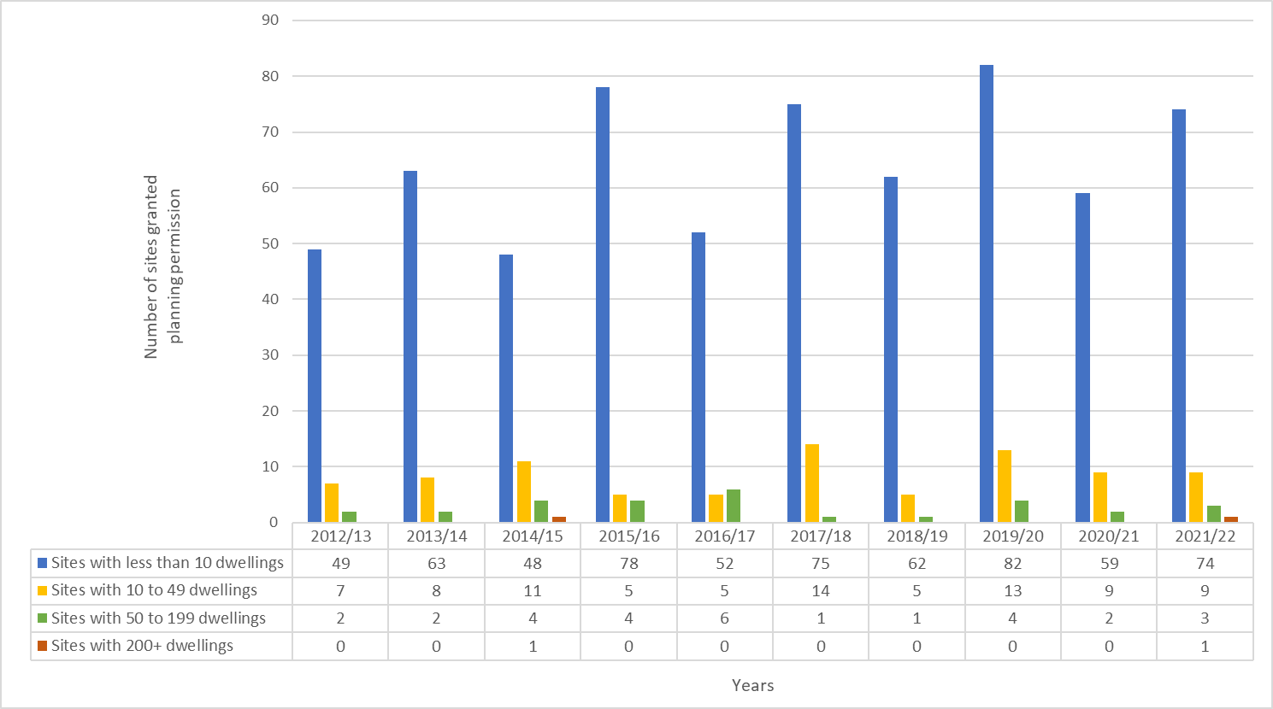

Figure 6: Number of dwellings with planning permission by site size 2012/13 to 2021/22
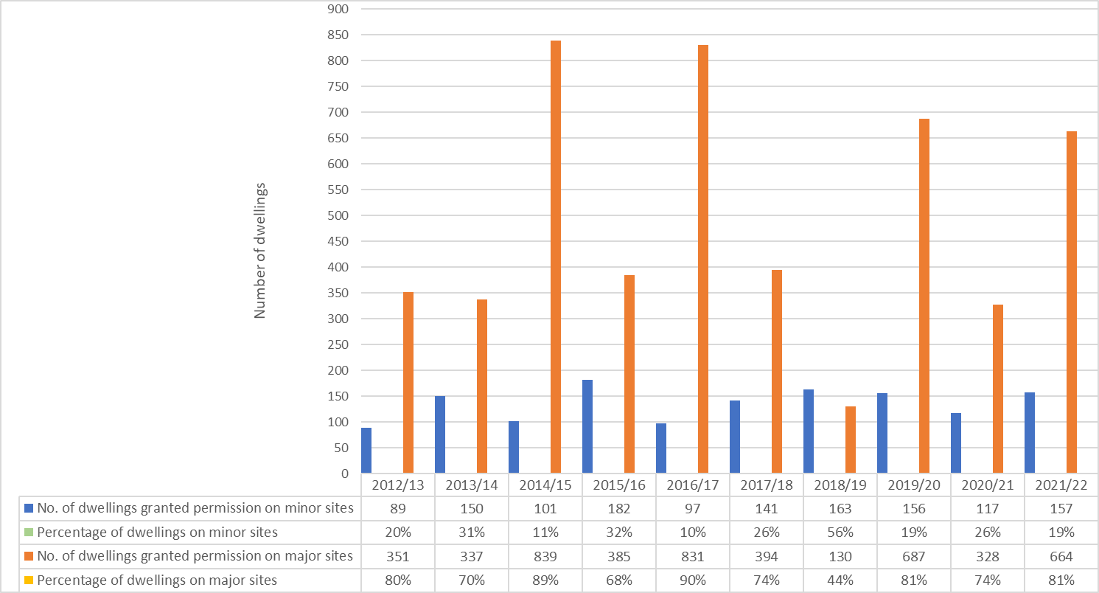

Build-out Rates
  - Analysis shows that on average larger schemes tend to be commenced faster than the smaller schemes as shown in table 5 below. This is possibly related to the fact that for larger schemes to come forward as an application in the first place there must be a certain level of investment and confidence in the deliverability of the site. There are also relatively few larger schemes so, again, any that do are more likely to be those where there is an active developer.
  - The build-out rates also show that larger sites tend to spend more time under construction, compared to smaller sites, however they deliver the greatest number of dwellings per year. This is likely due to phasing, build-out capacity and the need for supporting infrastructure to be constructed (such as roads).
  - Table 5 shows that all schemes which commence are built out within 5 years, and medium sites of 20-49 dwellings tend to be built out the quickest (within 2.08 years).
  - The relatively quick completion times and what appear to be healthy build-out rates are somewhat at odds with the level of development that is taking place in the borough. For example, as table 5 shows, it appears that if a scheme does commence, it tends to get built quickly. However, the analysis shows that there is an issue with planning permission being implemented (a 12% overall lapse rate) and also in terms of the scale of development coming forward, with only two large-scale major schemes (200+ homes) at Foxdenton (2014/15) and Cowlishaw (2021/22) receiving planning permission in recent years.
  - This may be due to the lack of large-scale allocations and land availability. However, it is expected that the development of large-scale sites will improve in the next 5-10 years, with key development sites within Oldham Town Centre and several of the PfE Strategic Allocations expected to begin to come forward. Moreover, the Local Plan will consider the need for large scale sites, through site allocations.
  - With regards to minor sites, the build-out rates indicate that where they are for individual houses there may not be the impetus or the ability to deliver the dwelling quickly, owing to constraints such as cost or availability of construction materials and labour.

Table 5: Lead-in times and build-out rates
Size of Site (dwellings) | Time from PP to first commencement (range) | Time from PP to first commencement (average) | Average time from PP to site completion | Average time from commencement to completion | Average no. of dwellings completed p.a
100+ | 3-22 | 25 | 52 | 34 | 66
50-99 | 1-35 | 12 | 40 | 24 | 46
20-49 | 1-39 | 10 | 25 | 14 | 35
10-19 | 1-35 | 12 | 30 | 20 | 11
6-9 | 1-44 | 15 | 35 | 19 | 8
0-5 | 1-56 | 14 | 28 | 18 | 2

- Housing Land Supply Analysis

Housing Land Supply

  - Analysis within this section is based on the housing land supply as of 1 April 2023 as identified in the council’s SHLAA and Monitoring Report.
  - The SHLAA (as of 1 April 2023) identifies a baseline housing land supply of 13,163 homes. This increases to 13,870 homes when including small sites and clearance allowances. A breakdown of the housing land supply as of 1 April 2023 is shown in table 6.
  - Table 6 shows that 24% of the supply is on sites within the planning system. This includes those that are under construction and those which have extant planning permission (outline and full). A further 10% is on sites which have been considered within the planning system, including existing Saved UDP Housing Allocations and sites which have previously had planning permission but where the permission has since lapsed, or the site has stalled. Approximately 47% of the housing land supply is on potential sites and those which are pending a decision on a planning application for residential development.
  - The housing land supply for 2023 includes the PfE Strategic Allocations for residential (or mixed-use) development.
  - Two sites within the PfE Strategic Allocations, are included within the housing land supply relative to their respective planning status i.e. Under Construction, as they have received planning permission in previous supply years and are under construction:
  - HLA3862 Cowlishaw Abbatoir, Shaw which is part of PfE Allocation JPA14 Cowlishaw and received planning permission (RES/346720/21) in January 2022 for 201 dwellings. The site is now under construction; and
- HLA3966 Land to the south of Denbigh Drive, Shaw which is part of PfE Allocation JPA14 Cowlishaw and received planning permission (FUL/346529/21) in May 2022 for 42 dwellings. The site is now under construction.
  - The remaining allocations (and a remaining undeveloped parcel at the Cowlishaw allocation) are included within their own category ‘PfE Strategic Allocations’ within the housing land supply. This category includes 2,481 homes, which equates to 19% of the total housing land supply.

Table 6: Breakdown of the housing land supply as at 1 April 2023
SHLAA category | Total dwellings 2023-2028 | Total dwellings 2028-2033 | Total dwellings Years 11+ | Total dwellings - all periods | % of supply (dwellings) | Total of number of sites | % of supply (sites)
Sites under construction | 1,241 | 0 | 0 | 1,241 | 9% | 123 | 28%
Sites with extant planning permission | 1,476 | 460 | 0 | 1,936 | 15% | 172 | 39%
Saved UDP Phase 1 housing allocations | 7 | 358 | 0 | 365 | 3% | 8 | 2%
Saved UDP Phase 2 housing allocations | 0 | 181 | 0 | 181 | 1% | 5 | 1%
Lapsed and Stalled sites | 61 | 508 | 147 | 716 | 5% | 36 | 8%
Potential & pending sites | 417 | 2,410 | 3,416 | 6,243 | 47% | 95 | 21%
PfE Strategic Allocations | 0 | 1,299 | 1,182 | 2,481 | 19% | 7 | 2%
SUBTOTAL | 3,202 | 5,216 | 2,045 | 13,163 | 100% | 446 | 100%
Current small sites allowance minus any small sites already identified in supply | 0 | 365 | 438 | 803
Current clearance allowance | 30 | 30 | 36 | 96
TOTAL | 3,172 | 5,551 | 5,147 | 13,870

Current Position of Housing Allocations
  - UDP Phase 1 and Phase 2 Housing Allocations have been saved as part of the Local Plan through Policy 3 ‘An Address of Choice’ with the intention being at the time that these would be assessed as part of the preceding Site Allocations Development Plan Document (DPD). However, progress regarding the Site Allocations DPD was put on hold in light of the Greater Manchester Spatial Framework (now Places for Everyone). Going forward allocations will be considered as part of the emerging Local Plan review. Upon adoption these will sit alongside the strategic allocations identified as part of Places for Everyone).
  - The UDP organised the housing allocations into two phases – phase 1 sites which were intended to meet short- and medium-term needs, and phase 2 sites which form a pool of sites for the longer term or in circumstances where the monitoring process indicates that there is likely to be a sustained shortfall in the envisaged phase 1 supply. These phasing arrangements are no longer considered applicable.
  - Analysis of the phase 1 housing allocations indicates that 57%, or 12, of the 21 allocations have been completed. There are nine phase 1 housing allocations remaining:
- Two form part of a wider mixed-use allocation which include active employment uses (land at Oldham Road / Hardman Street (M3) and Huddersfield Road / Dunkerley Street (M4). Part of the allocation at Oldham Road/ Hardman Street has extant planning permission for residential development (FUL/346821/21 – 14 homes);
- One site is the subject of a pending planning application for residential development (FUL/350293/22 - 60 homes) (Bailey Mill H1.1.5);
- Three are active employment sites (Pretoria Road (H1.1.23), Jowett Street (H1.1.25) and the remaining land of H1.1.24 fronting Rochdale Road, Royton; and
- Two have received planning permission in the past, and either the S106 has not been signed (Springhey Mill (H1.1.21)) or the permission has lapsed (Blackshaw Lane (H1.1.29)) therefore their status has reverted to allocated.
  - Hartford Mill (H1.1.27) received planning permission for demolition and redevelopment in 2019 - demolition has since been carried out. A detailed application for major residential development on the site is currently being prepared.
  - For the remaining phase 1 allocations there may be issues preventing these sites from coming forward, whether it be site constraints, multiple ownerships or viability issues. Whilst it is considered through the annual SHLAA assessment that the sites are deliverable, and there is no known reason for these sited not coming forward, the existing UDP housing allocations will be reviewed as part of the Local Plan Review to determine their future uses.
  - In terms of the phase 2 housing allocations, six out of the eight allocations remain within the housing land supply. Planning permission has been granted for 234 dwellings in total on Land at Knowls Lane (H1.2.10) (approximately 121 dwellings on the housing allocation). Three dwellings recently granted planning permission are under construction on a small part ofAshton Road, Woodhouses (H1.2.3) , whilst the remaining part of the allocation currently remains undeveloped. There is also an application pending decision for residential development at Lilac View Close (H1.2.6).

Lapsed and Stalled Sites
  - This category includes sites that have previously had planning permission for housing but where this has expired before being implemented. It also includes “stalled” sites which are classed as those that have been granted permission and construction has begun (or a material start has been made) but where there has been no development activity for at least five years.
  - In the lapsed and stalled category there are 25 sites of 10 dwellings or more, with the capacity to provide 929 dwellings. Six of these sites have a capacity of between 50 to 199 dwellings. These are listed in table 7 below. There are no sites of 200+ dwellings.

Table 7: Lapsed and stalled sites with a capacity of 50 dwellings and above, as at 1 April 2023
Site name | Land Type | Area (ha) | Dwellings
53 - 55 King Street (formerly Riley Snooker Club and Megson and Ponsonby Solicitors), Oldham, OL8 1EU | BF | 0.15 | 126
Phoenix Mill, Cheetham Street, Failsworth,  Manchester, M35 9DS | BF | 1.46 | 89
Land at North Werneth Zone 5, Land bounded by  Hartford Mill to the west, Edward Street to the north, and Milne Street to the east. | BF | 1.39 | 72
Land at Derker (Abbotsford Road Site), Abbotsford  Road/ Vulcan Street, Derker, Oldham | BF | 1.18 | 51
  - Since the previous HDT Action Plan, published in 2022, Thornham Mill, a previously large-scale lapsed site, has received planning permission for 60 dwellings.
  - One site with lapsed planning permission (Land at Springhead Quarry) has been discounted from the housing land supply as part of the updated SHLAA, as it is no longer considered suitable for residential development.
  - Several other lapsed and stalled sites have been assessed and amended as part of the SHLAA 2023 update, including amending site capacity based on updated constraints/ density assumptions and amending site boundaries to remove completed parts of sites, for example.
  - The reasons for these lapsed sites are varied. They are all brownfield sites, and some are in active employment use and therefore may have issues regarding the viability and other constraints that need to be overcome. The former Hartford Mill was derelict and having a detrimental impact on the surrounding area and preventing some sites at North Werneth from coming forward. However, as set out above, demolition has since been carried out and as such it is anticipated that the remaining surrounding sites at North Werneth will start to come forward soon. One formerly vacant site in this area – Land at North Werneth Zone 4 – has recently completed the development for 68 homes.
  - For these reasons, the majority of the sites are identified in the post five-year housing land supply as developable in years 6 to 10 and 11+ recognising the constraints that need to be overcome in order to secure their delivery. However, Land at Derker (Abbotsford Road Site), was identified within the five-year supply (2023-2028) as it is council owned and at the time was the subject of a pending planning application (as part of wider development of three sites within the area - FUL/350118/22). This application has since received planning permission (April 2024).

Housing Land Supply by Land Use
  - A significant proportion of the housing land supply as at 1 April 2023 includes sites that are currently in other uses, such as employment, but there are reasons to assume that housing could be achievable on the site in future. A portion of the housing land supply is also on sites in key locations such as Oldham Town Centre, and on sites which are in council ownership. Table 8 overleaf sets out the supply by land use.

Table 8: Breakdown of Housing Land Supply by Land Use
 | Total no. of sites | Total no. of dwellings | % of sites in active employment use (whole or in part) | % of dwellings on sites in active employment use (whole or in part) | % of sites on mill sites | % of dwellings on mill sites | % of sites within Oldham Town Centre | % of dwellings on sites within Oldham Town Centre | % of Council owned sites | % of dwellings on Council owned sites
% of supply |  |  | 9% | 22% | 6% | 16% | 13% | 26% | 13% | 43%
Number of sites/ dwellings | 446 | 13,163 | 39 | 2,872 | 25 | 2,170 | 60 | 3,448 | 60 | 5,624

  - Table 8 shows that 9% (39 sites) of the total number of sites in the housing land supply (446 sites) are in active employment use, which represents 22% (2,872 dwellings) of the total number of dwellings in the housing land supply (13,163 dwellings).
  - 6% (25 sites) of the total number of sites in the housing land supply are on mill sites, which represents 16% (2,170 dwellings) of the total number of dwellings in the housing land supply. In addition, to the 39 sites in active employment use, some of these mills are also in active employment use.
  - 13% (60 sites) of the total number of sites within the housing land supply are within Oldham Town Centre, representing 26% (3,448 dwellings) of the total number of dwellings in the housing land supply.
  - Finally, 13% (60 sites) of the total number of sites within the housing land supply are council-owned. This represents 43% (5,624 dwellings) of the total number of dwellings in the housing land supply.
  - For currently occupied sites, reasons which may make such a site suitable for inclusion within the housing land supply include:
- the site has been suggested as potential housing land in the future through the Call for Sites process by the owner;
- it is within an existing predominantly residential area;
- land adjacent to or close to the site has been granted planning permission for housing and this may have changed the character of the area;
- it is not fully occupied or is no longer fit for purpose to meet modern business needs or practices; or
- circumstances have changed which means that a current or former use is no longer viable or appropriate.

Housing Land Supply by Type
  - Table 9 below shows that 61% of all homes identified as part of the housing land supply is on brownfield land. This does not include the brownfield element of ‘mixed’ sites, which are a mix of brownfield and greenfield land. A further 15% of the housing land supply is on mixed sites. As such, 76% of the housing land supply is on brownfield or mixed sites.

Table 9: Breakdown of Housing Land Supply as at 1 April 2023 by Land Type
Category | Brownfield | Greenfield | Mixed | Total
Under construction | 754 | 122 | 365 | 1,241
Extant planning permission | 1,004 | 553 | 379 | 1,936
Saved UDP Phase 1 housing allocations | 350 | 0 | 15 | 365
Saved UDP Phase 2 housing allocations | 0 | 181 | 0 | 181
Lapsed and stalled sites | 657 | 29 | 30 | 716
Potential & pending sites | 5,237 | 240 | 766 | 6,243
PfE Strategic Allocations | 0 | 2,121 | 360 | 2,481
Total | 8,002 | 3,246 | 1,915 | 13,163
  - 84% of the new homes identified on potential and pending sites and 92% on lapsed and stalled sites fall on brownfield land. Therefore, there is a need to continue to ensure that brownfield sites come forward for development. As outlined below a significant proportion of these sites are for between 50 to 199 homes and 200+ homes, offering opportunities to broaden the scale of development opportunities across the borough.

Housing Land Supply by Size
  - Table 10 shows that 44% of the supply is made of large-scale major sites (200 dwellings and above) and 35% on sites of between 50 and 199 dwellings. 16% of the supply is on sites with a capacity of 10 to 49 dwellings and 6% of the supply is on minor sites with a capacity to deliver less than 10 dwellings. In total, 95% of the supply is made up of major sites (10 dwellings and above).
  - The supply identifies that out of 163 major sites, only 15 of them are identified as large-scale major sites (200+ dwellings). Of the major sites, the average site size is 76 homes. This means that the average size of site is relatively small, however it is in keeping with the hectarage and physical characteristics of sites which make up the housing land supply in Oldham.
  - Compared to the housing land supply for previous years, the 2023 housing land supply includes more large-scale major sites (200+ dwellings) and sites of between 50-199 dwellings. These are mainly due to the inclusion of the PfE Strategic Allocations, as shown below, but are also due to capacity amendments to existing sites in line with new evidence:
- JPA10 Beal Valley – 482 dwellings
- JPA12 Broadbent Moss – 1,374 dwellings
- JPA13 Chew Brook Vale – 138 dwellings
- JPA14 Cowlishaw – 222 dwellings
- JPA15 Land south of Coal Pit Lane – 175 dwellings
- JPA16 South of Rosary Road – 60 dwellings
  - PfE Strategic Allocation JPA11 Bottom Field Farm is also included within the housing land supply but has a capacity of less than 50 dwellings (30 dwellings). The council will support the delivery of several of these allocations, including Beal Valley, Broadbent Moss, Chew Brook Vale, Land south of Coal Pit Lane and South of Rosary Road. Whilst the remaining allocations are likely to be delivered independently in line with landownerships.
  - As such, the 2023 housing land supply has identified an additional 6 large-scale sites with a capacity to deliver an additional 3,047 dwellings, compared to the 2022 housing land supply (and an addition of 6 large-scale sites with an additional capacity of 3,027 dwellings compared to the 2021 housing land supply).
  - The potential and pending site category include the most sites of between 50-199 dwellings and sites of 200+ dwellings. 83% of the total number of sites within this category are identified as being capable of delivering 50-200+ dwellings. The dwellings identified on sites of this size within the potential and pending category represent 39% of all dwellings identified within the housing land supply.
  - The potential sites provide an opportunity to respond to some of the issues identified by the evidence in relation to build-out rates and the lack of larger sites coming forward for development. However, a number of these sites are still identified within the long-term supply period, with some capacity even falling post-plan period (post-2039). As such, there is still a need to identify opportunities to bring large sites forward sooner.

Table 10: Breakdown of Housing Land Supply as at 1 April 2023 by Size
Category | Total no. of sites | Total no. of dwellings | No of sites <10 dwellings | No of dwellings on sites of <10 dwellings | No. of major sites of 10 to 49 dwellings | No. of dwellings on major sites of 10 to 49 dwellings | No. of major sites of 50 to 199 dwellings | No. of dwellings on major sites of 50 to 199 dwellings | No. large scale major sites (200+ dwellings) | No. of dwellings on large scale major sites (200+ dwellings)
Under construction | 123 | 1,241 | 99 | 231 | 19 | 419 | 4 | 390 | 1 | 201
Extant planning permission | 172 | 1,936 | 151 | 303 | 13 | 252 | 5 | 382 | 3 | 999
Lapsed and stalled sites | 36 | 716 | 15 | 94 | 17 | 284 | 4 | 338 | 0 | 0
Phase 1 Housing Allocations | 8 | 365 | 0 | 0 | 5 | 107 | 3 | 258 | 0 | 0
Phase 2 Housing Allocations | 5 | 181 | 0 | 0 | 3 | 55 | 2 | 126 | 0 | 0
Potential & pending sites | 95 | 6,243 | 18 | 118 | 43 | 953 | 26 | 2713 | 8 | 2459
PfE Strategic Allocations | 7 | 2,481 | 0 | 0 | 1 | 30 | 3 | 373 | 3 | 2078
Total | 446 | 13,163 | 283 | 746 | 101 | 2100 | 47 | 4580 | 15 | 5737

Oldham Town Centre
  - The large-scale major sites and sites of between 50-199 dwellings include key sites within Oldham Town Centre,which form part of the council’s Town Centre Development Framework. The Development Framework is guided by the vision established in the ‘Creating a Better Place’ Strategic Framework which is outlined in section 1 of this report. A key part of the Development Framework is to support the delivery of development opportunity sites, which are within council-ownership, for housing and mixed-use development.
  - Whilst this is an emerging project and identified sites and indicative capacities may change as evidence develops, several of the development opportunity sites are identified within the housing land supply for 2023 (within the Potential and Pending site category), as set out below:
- Civic Centre, West Street with an indicative capacity of 682 homes;
- Land between Prince Street, Oldham Way and Mumps, and Land at Mumps and Wallshaw Street, with an indicative capacity of 348 homes across both sites;
- Former Magistrates Court and Manchester Chambers, Barn Street with an indicative capacity of 240 homes;
- Former Leisure Centre Site, Lord Street with an indicative capacity of 215 homes;
- Land at Waterloo Street with an indicative capacity of 190 homes;
- Bradshaw Street with an indicative capacity of 120 homes; and
- Henshaw House with an indicative capacity of 45 homes.
  - The Town Centre Development Framework will support the master planning and delivery of these large-scale sites, which coupled with the delivery of the PfE Strategic Allocations, will directly respond to an issue identified within the previous Housing Delivery Test Action Plan of a limited number of large-scale sites coming forward for development.

Housing Land Supply by Owner
  - As table 11 shows 25% of the housing land supply is on local authority owned sites. These sites offer significant opportunities to boost housing delivery across the borough in line with the council’s priorities. In addition to this, a proportion of the mixed ownership category includes sites which are also part-owned by the local authority, which presents the opportunity for new ways of partnership working to bring these sites forward.
  - There is also a proportion of sites owned by other public bodies providing the opportunity for partnership working, and sites owned by Registered Affordable Housing Providers enabling the delivery of new affordable homes.

Table 11: Breakdown of housing land supply as at 1 April 2023 by landowner
 | Local Authority | Registered Provider | Other public body | Private | Mixed | Total
Under construction | 247 | 0 | 0 | 994 | 0 | 1,241
Extant planning permission | 0 | 88 | 0 | 1,834 | 14 | 1,936
Saved UDP Phase 1 housing allocations | 15 | 0 | 0 | 192 | 158 | 365
Saved UDP Phase 2 housing allocations | 78 | 0 | 0 | 103 | 0 | 181
Lapsed and stalled sites | 23 | 0 | 0 | 552 | 141 | 716
Potential & pending sites | 2,870 | 0 | 0 | 3,074 | 299 | 6,243
PfE Strategic Allocations | 0 | 0 | 0 | 625 | 1,856 | 2,481
Total | 3,233 | 88 | 0 | 7,374 | 2,468 | 13,163

Five-year Housing Land Supply Position
  - The SHLAA as at 1 April 2023 sets out the council’s latest five-year housing land supply position. The housing land supply is constantly evolving with new sites gaining permission, sites being completed and potential land coming forward.
  - The Department of Levelling Up, Housing and Communities (DLUHC) (formerly Ministry of Housing and Local Government (MHCLG)) introduced a methodology for calculating local housing need in 2018. Where a Local Plan is more than five years old, as per paragraph 74 of the NPPF, the local housing need calculation (standard methodology) applies when calculating the authorities five-year housing land supply.
  - At the time of the publication of the SHLAA in January 2024, Oldham's current local housing need was determined by the standard methodology, which identified a housing need of 703 new homes per year. The five-year housing land supply identified within the SHLAA 2023 represented a supply 4.5 years or 90% of the total housing required (against the standard methodology requirement) for the period (2023-2028).
  - Section 6 of the SHLAA 2023 also set out Oldham’s five-year housing land supply against the PfE housing requirement for Oldham. At the time of publication of the SHLAA, PfE was an emerging Plan which would become part of Oldham’s statutory development plan following its adoption. PfE was adopted by the nine Places for Everyone authorities on 21 March 2024, and as such, PfE now sets out Oldham’s housing requirement over the plan period (2022- 2039).
  - PfE identifies a stepped housing requirement for Oldham of 404 homes per year for 2022-2025, 680 homes per year for 2025-2030, and 772 homes per year for 2030-2039. The stepped requirement equates to an average of 680 homes per year. Across the plan period the total housing need for Oldham is 11,560, including a buffer to provide flexibility.
  - Oldham’s housing requirement for the five-year period of 2023-2028 is therefore the five-year average of the remaining two years of the stepped requirement of 404 homes per year which apply to 2022-2025 and three years of the stepped requirement of 680 homes per year which apply to years 2025-2030. The increase in housing requirement at each ‘step’ presents a challenge in ensuring the delivery of housing can be maintained in line with the requirement. Whilst the requirement has been devised based on identified housing land supply over the plan period, the actual delivery of the identified supply remains important in ensuring this is met in a timely manner.
  - Oldham’s five-year supply (2023-2028) is 3,202 homes. Against Oldham’s current housing requirement identified in PfE, Oldham’s identified housing land supply represents 111% or a 5.5-year supply of deliverable housing land. As such, the five-year housing land supply is sufficient to meet the stepped requirement and provides an appropriate flexibility allowance to allow for changes in supply and/or delivery.
  - The five-year housing land supply position is updated annually and is published as part of the SHLAA and authorities Monitoring Report.
  - The post five-year housing land supply identifies a further 9,961 dwellings which are expected to be delivered beyond 2028 (including 552 dwellings expected to be delivered beyond 2039). These are on sites that would either require a full or reserved matters application, a new planning application, construction would need to resume or, for potential and pending sites, be granted planning permission for housing.

- Engagement

  - As set out in section 1, in February 2024 Oldham Council held a Housing Roundtable event. Senior representatives from all of Oldham's major social housing providers were at the event, along with private landlords, letting agents, developers and housebuilders, charities and more.
  - Some of the main issues discussed include:
  - the national problem of a shortage of housing supply, driven by factors such as the high costs of renting and home ownership;
- the lack of Government funding to invest in social homes;
- differences in the definition of truly "affordable" homes, and a reduction in the supply of social and affordable housing.
  - Nationally, the Government has stopped incentivising developers to build truly affordable homes, with funding provided through the Government's Affordable Homes Programme (AHP) being slashed, which intensifies the need further.
  - At the same time, demand for those homes is increasing, as people are affected by the cost-of-living crisis and are struggling with rising mortgage interest rates - meaning they may not be able to afford to pay, or get on the housing ladder at all.
  - Risks of further increasing housing demand pressures were also identified as population growth, people living independently for longer, increasing risk of homelessness and the lack of properties available.
  - Local issues such as housing standards, housing demand and supply were discussed and the council and the partners considered how they could work together to tackle the issues locally.
  - As part of this Roundtable event, the council – with the support of its partners - pledged to build 500 new social homes over the next five years for residents to meet local housing needs.
  - Following on from this event, a workstream of actions was developed. The actions are a shared responsibility across various teams at the council and each action relates to distinct issue areas, such as housing supply, including affordable and social housing.
  - Actions related to housing supply include, tackling empty homes, bringing them back into use and identifying a residential pipeline – a live database which clearly sets out a supply of future housing and includes a breakdown of housing tenure and indicative delivery period.
  - Further information and progress on these actions are included within part 2 of this Action Plan.
  - In addition to the Roundtable event, regular engagement with key housing delivery stakeholders is carried out through the Strategic Housing Group. This group meets around every 3 months and brings to together Registered Providers, Developers, Council Officers, elected Members and other key stakeholders. It provides strategic direction and advice on key housing issues facing the borough and oversees the delivery of the Housing Strategy Action Plan, which includes ways to increase housing delivery and supply.
  - Furthermore, as part of the engagement carried out for previous HDT Action Plans, several potential reasons for the under-delivery of housing were found and potential solutions identified. Many of these are still applicable and the evidence continues to inform actions identified for improving housing delivery within this Action Plan (as identified in part 2).
  - For example, to inform the preparation of the HDT Action Plan in 2021 a housing delivery developer questionnaire was sent to identified developers, housebuilders, registered providers and agents operating in the borough. The questionnaire sought views and comments on housing delivery issues and opportunities in Oldham.
  - The main findings in terms of how prolific housing delivery issues are in Oldham compared to other Greater Manchester authorities, were that in general housing delivery issues affecting Oldham were not unique to the borough and indeed it is considered that the issues are apparent across Greater Manchester boroughs. However, some respondents noted that the tightly defined Green Belt in Oldham, particularly to the east of the borough, is an issue for Oldham in particular.
  - It was also noted that generally low house prices, viability and difficult brownfield sites were an issue in Oldham. Although respondents highlighted those issues of low house prices were an issue across the east of Greater Manchester housing market area, in particular.
  - Appendix 2 of this document contains a full summary of responses to the questionnaire and the actions identified by respondents to tackle the issues.

  - Ongoing engagement with key housing delivery stakeholders is important to support housing delivery within the borough and will continue to be carried out.

- Summary of housing delivery and supply issues in Oldham

  - Analysis of housing delivery and the make-up of the housing land supply identifies several issues, which may impact housing delivery within the borough. In summary, these are:
- Delivery of Oldham’s housing requirement, as set out in PfE. The housing requirement is stepped over three periods and will increase significantly from 2025 onwards. It is important that housing delivery is maintained in line with the housing requirement.
- There is a need to deliver affordable housing to meet local housing needs, including social homes. The council, and its partners, have committed to delivering 500 social homes over the next five years.
- There is a need to continue to ensure that brownfield sites come forward for development - 76% of the housing land supply is on brownfield or mixed land, with a significant proportion (79% of the supply) on sites of between 50 to 199 dwellings and 200+ dwellings, offering opportunities to broaden the breadth of development opportunities across the borough.
- Scale of development coming forward – minor sites (of less than 10 dwellings) make up 84% of sites granted planning permission in the last ten years. Whilst the number of major sites coming forward is more limited, they continue to form a significant proportion of the supply, accounting for 75% of dwellings granted planning permission over the last ten years.
- 'Major’ sites in Oldham are still relatively small with most sites within the housing land supply (101 sites out of a total 163 major sites) having a capacity of under 50 dwellings, and the average site size of major sites is for 76 dwellings. However, the most recent update of the housing land supply (as at 1 April 2023) has identified additional 'large-scale major' sites (over 200 dwellings).
  - Number of major sites of 10 to 49 dwellings – 101
  - Number of major sites of 50 to 199 dwellings – 47
  - Number of large-scale major sites of 200+ dwellings – 15
- We need to continue to increase the number of major sites coming forward and support them in delivery where appropriate, in particular those with a capacity of 100 to 200+ dwellings as the analysis indicates that these are more attractive for housebuilders and appear to be developed faster.
- Build-out rates - larger schemes are being commenced faster than smaller ones. Yet, as outlined above the number of major sites coming forward is relatively limited at present. However, the number of large-scale sites is expected to increase in line with the identified future housing land supply, including large-scale sites within Oldham Town Centre and the PfE Strategic Allocations expected to come forward over the next 5-15 years.
- Delivery of minor sites - evidence indicates that for minor sites where they are for individual houses there may not be the impetus or the ability to deliver the dwelling quickly, owing to constraints such as cost or availability of construction materials and labour.
- Over-reliance on sites outside the planning system – with 76% of the housing land supply (as at 1 April 2023) made up of potential housing sites that do not currently have any planning permission (although some may have been considered for housing through the planning system such as those with lapsed permissions and identified allocations).
- Issues around the implementation of planning permissions which may, for example, be due to viability and deliverability.
- Availability of grant support to help bring sites forward, such as GMCA Brownfield Land Fund and One Public Estate Brownfield Funding, are geared towards larger sites.
  - Actions to tackle these housing delivery and supply issues will be considered in part 2 of this Action Plan.
- Appendices
Appendix 1 - Implementation rates from 01/04/2012 to 31/03/2022
Year | No. of sites granted permission | Capacity of sites granted permission | No. dwellings completed on these sites | No. dwellings under construction on these sites | No. dwellings not started but development has been implemented on these sites | No. dwellings not started but site still has extant permission/prior approval | No. dwellings lapsed on these sites | Overall lapse rate (%) | Housing Requirement
2012/13 | 58 | 440 | 395 | 14 | 33 | 0 | 43 | 9.7% | 289
2013/14 | 75 | 481 | 406 | 9 | 5 | 0 | 50 | 10.3% | 289
2014/15 | 64 | 940 | 549 | 58 | 39 | 0 | 49 | 5.2% | 289
2015/16 | 87 | 567 | 486 | 7 | 10 | 0 | 59 | 10.4% | 289
2016/17 | 63 | 928 | 479 | 7 | 138 | 0 | 257 | 27.6% | 446
2017/18 | 90 | 535 | 392 | 15 | 33 | 0 | 74 | 13.8% | 660
2018/19 | 68 | 293 | 212 | 41 | 3 | 0 | 20 | 6.8% | 717
2019/20 | 99 | 843 | 399 | 35 | 13 | 0 | 74 | 8.7% | 633
2020/21 | 70 | 445 | 258 | 58 | 58 | 45 | n/a | n/a | 461
2021/22 | 86 | 820 | 250 | 197 | 252 | 131 | n/a | n/a | 677
TOTAL | 760 | 6,292 | 3,826 | 441 | 584 | 176 | 626 | 11.6% | 4,750

Appendix 2 - Housing Delivery Questionnaire 2021 Responses

  - The following table provides a summary of the issues that were highlighted by respondents to the housing delivery questionnaire which was sent out to inform the HDT Action Plan in 2021.
Main Issue Theme | Issues
General lack of appropriate sites | Lack of appropriately sized, available and suitable sites in good locations.  Large amounts of constrained sites in terms of topography, contamination and demolition costs, present significant viability challenges.  Unrealistic expectations of land values slow the process and increase costs of development.  Oldham's market forces mean that not all available sites are in locations where housebuilders want to build/ where there is strong housing market demand.  Over-reliance on town centre and brownfield sites will not provide homes in the right locations.
Constrained/ complex development sites | Green Belt policy means housing development is limited to constrained brownfield sites.  Site constraints lead to delays in land negotiations, planning application process and onsite delivery.  Industrial legacy has contributed to the identification of several difficult-to-deliver brownfield sites.
Economic/ housing market uncertainty | Removal of Stamp Duty and the Government's Covid-19 Furlough Scheme could impact on the economy and therefore affect the housing market, including delivery of affordable housing.  Affordable rents are linked to market values and could be detrimentally impacted if market conditions worsen.  Some economic uncertainty but the housing market remains strong.
Issues of development viability | Increasing construction and material costs are impacting on viability and deliverability.  Viability is a key issue for brownfield sites, which are typically located in lower value/ weaker housing market areas and have numerous constraints to overcome.  Viability is a significant issue for affordable housing delivery - complex sites, low market rental and sales values and high land values. Market rent value is particularly difficult to deliver.  The introduction of measures associated with a move to Net Zero Carbon will worsen viability without government subsidy.
Affordable housing and other policy requirements | The provision of affordable housing is less of a constraint than other policy requirements.  The quality bar should be set high but should reflect the local market. Trade-offs between policy requirements are inevitable.  Need to build more affordable housing at public expense, not rely on the private sector.
S106 negotiations | Negotiations are slow and over-complicated for what is a standard legal process.  S106 acquisitions for affordable housing are competitive and unfair.  The legal signing-off process causes delays.
Planning application process | Decision-making/ assessment is too bureaucratic, and process based.  Statutory consultees are under-resourced leading to lengthy response times which in turn slows the whole process.  Lack of certainty around requirements and inconsistent messaging from different departments.  The planning department is under-resourced, particularly highways leading to a lengthy application process.  The pre-application process is too lengthy.  Delays are caused by a lack of capacity to process applications, lack of delegated officer decisions and too many applications requiring planning committee approval.  Difficult to maintain communication during the planning application process.  'Approval in Principle' would speed up the process.  External consultants employed by the council to assist in applications take too long to respond.
Pre-commencement conditions | Many are unnecessary and should be cleared at approval, especially those where details are included in the initial application e.g. landscaping, boundary treatments and materials.  Time consuming to discharge conditions after approval.
Infrastructure/ utilities provision | Perceived lack of local infrastructure and facilities is driving public objections to housing developments.  Schemes are delayed by statutory services and their procedures; Infrastructure providers have a monopoly on the market, meaning costs can be high and impact on development viability.
Build process (construction, labour, funding etc.) | Covid-19 and Brexit have impacted on the availability of materials and labour causing delays and increased costs.
Other issues | Lack of up-to-date Local Plan creates uncertainty in the development industry and leads to the current position of speculative development on employment sites and protected land, which is a risky, difficult and lengthy process.
  - The following actions/ improvements were identified by respondents in relation to the housing delivery issues:
- Better resourcing of planning departments and statutory consultees (not limited to Oldham);
- Need to ensure a streamlined post-approval process to agreeing S106 and discharging planning conditions;
- Strict deadlines for agreeing S106;
- Ensure planning conditions are proportionate to the development;
- Could introduce deemed approval of conditions after a short amount of time following submission of information;
- Housing mix and type of developments need to be market-facing;
- Large scale masterplans should ensure the development has a positive impact on the surrounding area, increasing land values, investment and regeneration;
- Need for clear planning policy which ensures real choice in housing;
- Decision-making should consider the merits of the scheme rather than standard 'box ticking';
- Early communication during the application process around development expectations, issues, requirements and application timescales is essential; Early, open and efficient pre-application discussions with the council and infrastructure providers;
- Efficient validation and consultation processes;
- Application determination within an appropriate time period should be met; Sufficient pre-approval discussion could deal with issues and agree conditions; Need to identify a better way to address and communicate infrastructure concerns with the public; and
- Oldham's new local and regional plan needs to provide a clear vision for the borough's future and guide development.
  - Respondents also highlighted the impacts of Covid-19 on housing delivery, including:
- The closure of construction sites for several months in 2020 and the implications of Covid-19 restrictions / social distancing requirements have, in some cases, led to delays in site completions, including some affordable housing;
- Long term impact of people continuing to work from home may lead to a change in housing demand - for example, decreased demand for flats, increased demand for homes with office space, more garden space, better access to parks and open spaces; and
- The wider financial impact of the pandemic impacting on resources available to deliver affordable housing.
- Longer-term analysis is needed to understand the longer-term impacts of the Covid-19 pandemic on housing delivery and will be kept under review.

HDT Results 2022: https://www.gov.uk/government/publications/housing-delivery-test-2022-measurement
Shelter ‘Let’s build social housing’ campaign: https://england.shelter.org.uk/support_us/campaigns/lets_build_social_housing#:~:text=A%20severe%20lack%20of%20social,to%20lead%20happy%2C%20healthy%20lives.
Oldham Council Housing Roundtable Event, February 2024: https://www.oldham.gov.uk/news/article/2618/tackling_the_housing_crisis_500_new_social_homes_coming_to_oldham_announced_at_oldham_housing_roundtable_event
Oldham's Housing Strategy, Oldham Council 2019, available at: https://www.oldham.gov.uk/info/200584/housing_strategies_and_research
Oldham Local Housing Needs Assessment (LHNA) (2019): https://www.oldham.gov.uk/downloads/file/5590/housing_strategy_needs_assessment_report_2019
'Creating a Better Place’, Oldham Council: https://www.oldham.gov.uk/info/201248/creating_a_better_place
https://www.oldham.gov.uk/info/201248/creating_a_better_place/3014/2000_new_homes
Joint Core Strategy and DPD (adopted 2011), available at: https://www.oldham.gov.uk/homepage/913/adopted_plans_and_guidance
Oldham Draft Local Plan, available at: https://www.oldham.gov.uk/info/201233/local_plan_review/3095/draft_local_plan
https://www.oldham.gov.uk/info/201233/local_plan_review
Local Development Scheme (2023): https://www.oldham.gov.uk/info/201231/emerging_planning_policy/230/local_development_scheme_timetable
Places for Everyone: https://www.greatermanchester-ca.gov.uk/what-we-do/planning-and-housing/places-for-everyone/
ONS Census 2021: https://www.ons.gov.uk/peoplepopulationandcommunity/birthsdeathsandmarriages/ageing/articles/profileoftheolderpopulationlivinginenglandandwalesin2021andchangessince2011/2023-04-03#:~:text=2.-,Population%20ageing,from%2016.4%25%20to%2018.6%25
The State of Ageing (2022), available at: https://ageing-better.org.uk/sites/default/files/2022-04/The-State-of-Ageing-2022-online.pdf
Tackling the under-supply of housing in England: https://commonslibrary.parliament.uk/research-briefings/cbp-7671/
ONS Housing Affordability (2023 release): https://www.ons.gov.uk/peoplepopulationandcommunity/housing/bulletins/housingaffordabilityinenglandandwales/2022
‘What 175 years of data tell us about house price affordability in the UK’, Schroders 2023: https://www.schroders.com/en/global/individual/insights/what-174-years-of-data-tell-us-about-house-price-affordability-in-the-uk/
ONS Opinions and Lifestyle Survey – Impact of increased cost of living on adults across Great Britain: July to October 2023: https://www.ons.gov.uk/peoplepopulationandcommunity/personalandhouseholdfinances/expenditure/articles/impactofincreasedcostoflivingonadultsacrossgreatbritain/latest#characteristics-associated-with-financial-vulnerability
ONS Opinions and Lifestyle Survey – Impact of increased cost of living on adults across Great Britain: July to October 2023: https://www.ons.gov.uk/peoplepopulationandcommunity/personalandhouseholdfinances/expenditure/articles/impactofincreasedcostoflivingonadultsacrossgreatbritain/latest#characteristics-associated-with-financial-vulnerability
ONS Opinions and Lifestyle Survey – Impact of increased cost of living on adults across Great Britain: July to October 2023: https://www.ons.gov.uk/peoplepopulationandcommunity/personalandhouseholdfinances/expenditure/articles/impactofincreasedcostoflivingonadultsacrossgreatbritain/latest#characteristics-associated-with-financial-vulnerability
Local Housing Need Assessment Update 2023/24 - ONS 2018-based population projections.
Source: Oldham in Profile 2024, Oldham Council - ONS Mid-Year Estimates, ONS SNPP 2020, Oldham Council Projections 2020
Source: Oldham in Profile 2024, Oldham Council - Department for Levelling up, Housing and Communities (2021-Present), Ministry of Housing, Communities and Local Government (2018-2021), Department for Communities and Local Government (2006-2018), English indices of deprivation
Oldham in Profile 2024, Oldham Council – ONS Annual Survey of Hours and Earnings 2022.
Oldham in Profile 2024, Oldham Council
ONS 2021 Census
Oldham in Profile 2024, Oldham Council.
Oldham Local Housing Needs Assessment Update 2023/24
Oldham in Profile 2024, Oldham Council – Land Registry data.
ONS ‘House price to workplace-based earnings ratio’, March 2024: House price to workplace-based earnings ratio - Office for National Statistics (ons.gov.uk)
Property Insider (ONS data 2023): https://propertyinsider.info/the-best-and-worst-areas-to-rent-a-home-in-greater-manchester/#:~:text=The%20rent%20affordability%20ratio%20of,their%20monthly%20salaries%20on%20rent.
M4(2) Accessible and adaptable dwellings (pages 10-23): https://assets.publishing.service.gov.uk/media/5a7f8a82ed915d74e622b17b/BR_PDF_AD_M1_2015_with_2016_amendments_V3.pdf
M4(3) Wheelchair user dwellings (pages 23-50): https://assets.publishing.service.gov.uk/media/5a7f8a82ed915d74e622b17b/BR_PDF_AD_M1_2015_with_2016_amendments_V3.pdf
NPPF and the HDT rulebook requires that where a local authorities Local Plan is more than five years old, local housing need should be calculated using the governments ‘standard methodology’. Oldham’s current Local Plan – The Joint Core Strategy and Development Management Policies DPD – was adopted in 2011. During the years of 2019/20 to 2021/22, which are considered by the 2022 HDT measurement, Oldham’s Local Plan was more than five years old. As such, the ‘standard methodology’ applied for calculating local housing need for this period. However, as Places for Everyone was adopted on 21 March 2024, and sets out Oldham’s housing requirement, in future HDT measurements the Places for Everyone housing requirement for Oldham will apply, as relevant to the year(s) being measured.
Measuring housing delivery compared to housing required over the previous three years. I.e. the 2018 measurement looks at housing delivery over the years 2015-2018.
Oldham's Monitoring Report 2022/23, Table 1 “Housing Completions Compared to Housing Requirement”, available at: https://www.oldham.gov.uk/info/200709/documents_in_the_local_development_framework/263/annual_monitoring_report
NPPF Annex 2: Glossary – ‘Affordable housing’: Housing for sale or rent, for those whose needs are not met by the market (including housing that provides a subsidised route to home ownership and/or is for essential local workers); and which complies with one or more of the following definitions. Including affordable rent, social rent, starter homes, discounted market sales, and other affordable routes to home ownership.
For housing, major development is defined as that of 10 or more homes or a site area of 0.5 hectares of more. Minor residential development is that which falls below these thresholds (NPPF, Annex 2 – Glossary).
Strategic Housing Land Availability Assessment (SHLAA) (as at 1 April 2023), available at: https://www.oldham.gov.uk/info/201230/monitoring/2134/strategic_housing_land_availability_assessment_shlaa
Oldham's Monitoring Report and Infrastructure Funding Statements 2022 to 2023, available at: https://www.oldham.gov.uk/info/201230/monitoring/263/oldhams_monitoring_report
A planning application (FUL/347760/21) is also pending decision (subject to legal agreement) for 30 dwellings at JPA11 Bottomfield Farm (Woodhouses).
Oldham Road/ Hardman Street (M3) received planning permission for residential development of 14 dwellings in January 2022. As permission was granted after the base period of the SHLAA as at 1 April 2021, the site’s status remains as undeveloped in the SHLAA as at 1 April 2021, however it will be updated in the next SHLAA update (as at 1 April 2022) as appropriate.
The total allocation capacity was for 1,450 dwellings. 77 dwellings were completed within the allocation (Hebron Street) in 2020.
The total allocation capacity is for 460 dwellings. Two out of three parcels within the allocation are currently under construction (Cowlishaw Abbatoir and Land south of Denbigh Drive) and included within the ‘Under Construction’ category within the housing land supply. 222 dwellings is the remaining un-permissioned capacity within the allocation.
https://www.gov.uk/guidance/housing-and-economic-development-needs-assessments
Oldham Council Housing Roundtable Event, February 2024: https://www.oldham.gov.uk/news/article/2618/tackling_the_housing_crisis_500_new_social_homes_coming_to_oldham_announced_at_oldham_housing_roundtable_event
From 2015/16 onwards, this column shows the housing requirement as is set out within the HDT measurement (applicable to the individual year), which takes into account previously unmet need/ under-delivery of housing against an adopted housing requirement or that identified by the standard methodology for calculating local housing need.

