PSPO 037/20
DOMAINOMBC

© Crown copyright (and database rights) 2018 OS license 0100019668

Production Date:
13th November 2020

Scale 500
when printed at A4

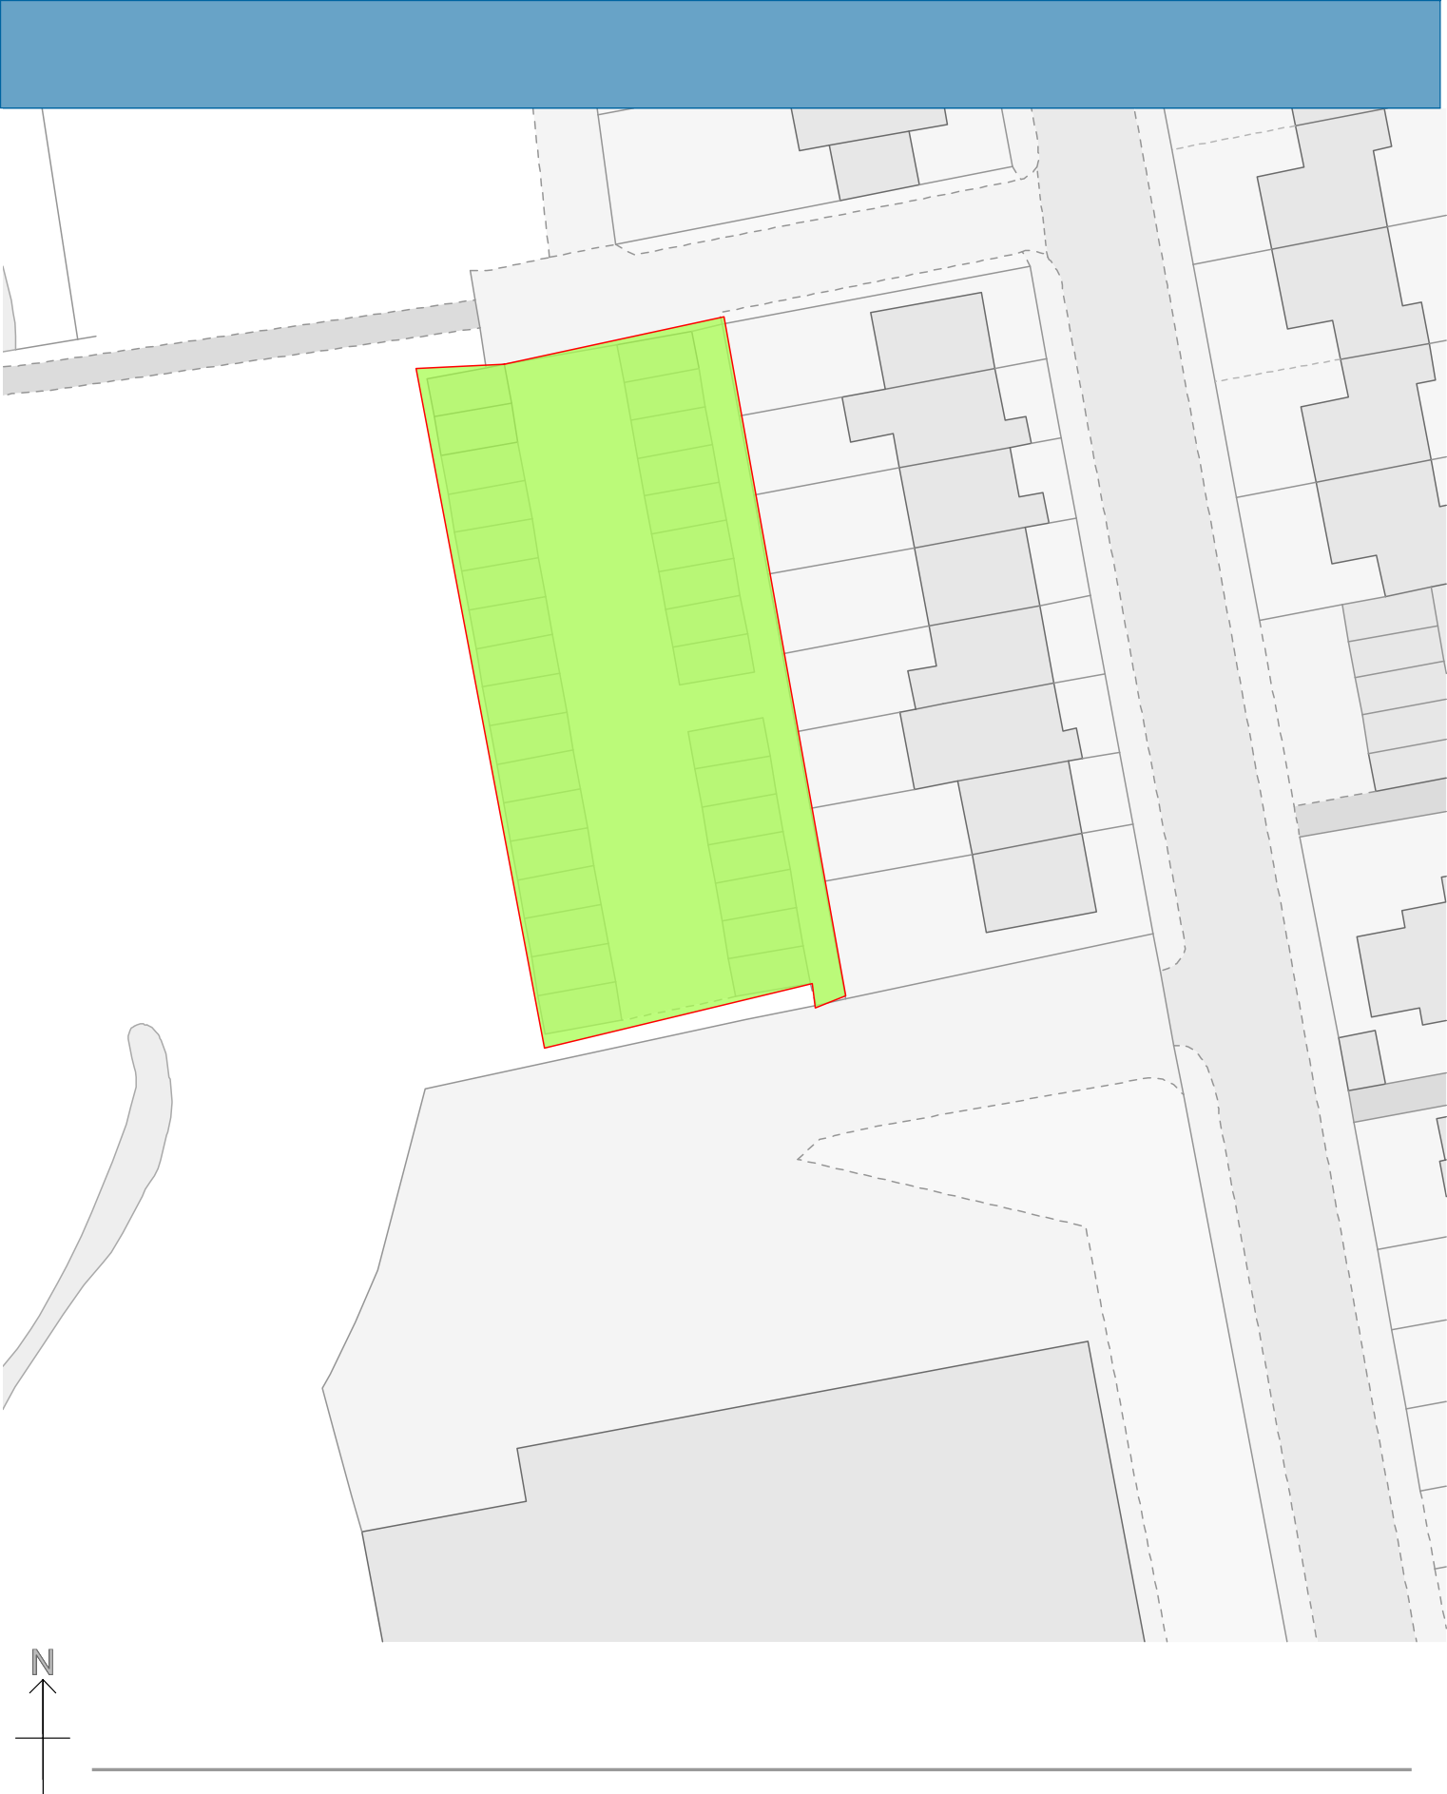

Notes

