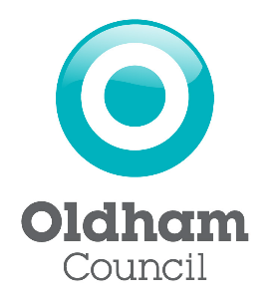

Guidance to Applicants

Private Hire and Hackney Carriage Driver Medicals

Group 2 Medical Requirements

As a new applicant, or existing Dual Driver, you must satisfy the DVLA Group 2 Medical Standards in order to hold, or continue to hold, a Dual Driver Licence.

You should try to obtain your medical from your own GP, as they have access to your full medical records.
If you cannot access your GP to obtain a Group 2 Medical, you can access a private company to do so.
If obtaining a private medical, the Doctor completing the form must have access to at least a summary of your medical records.

The D4 Medical Form can be found online using the link on our website under one of the following headings – ‘New Driver Application’ or ‘Renewal Driver Application’.

IMPORTANT: The GP carrying out your medical must sign a declaration to confirm whether you meet Group 2 Standards or not. Licensing Officers are not medical professionals and can only assess the information provided by the GP completing your medical. The declaration is below, and you should print this and take it to your appointment. If your GP does not sign the declaration, we may be unable to accept your medical certificate.

All completed medical and declaration forms should be handed into the Licensing Office.

Please see the following GP declaration form.

General Practitioner (GP) Declaration

Patient Name
Patient Address
Patient DOB

I certify that I have examined the above-named driver and have had access to at least a summary of their medical records.
Based on the assessment undertaken today I confirm the patient:

Has MET the DVLA Group 2 Medical Standard

Has NOT MET the DVLA Group 2 Medical Standard

Signature of GP
Date

Doctor Stamp:

